Reflection Report

  - Unit code: COS40006 EAT40006
  - Unit Name: Engineering Project B
  - Submission date: 09-06-25
  - Name: Nur E Siam
  - Student ID: 103842784

Acknowledgment of Country
I respectfully acknowledge the Wurundjeri People of the Kulin Nation, who are the Traditional Owners of the land on which Swinburne’s Australian campus is in Melbourne’s east and outer-east, and pay our respect to their Elders past, present, and emerging.
I am honoured to recognise our connection to Wurundjeri Country, history, culture, and spirituality through these locations, and strive to ensure that we operate in a manner that respects and honours the Elders and Ancestors of these lands.
I also respectfully acknowledge Swinburne’s Aboriginal and Torres Strait Islander staff, students, alumni, partners and visitors.
I also acknowledge and respect the Traditional Owners of lands across Australia, their Elders, Ancestors, cultures and heritage, and recognise the continuing sovereignties of all Aboriginal and Torres Strait Islander Nations.

Executive Summary
This report details my personal contributions and development throughout Engineering Projects A and B. In Capstone A, I was responsible for conducting research, administering a user survey, choosing an appropriate color palette, designing the user interface layout, and producing the final product poster. In Capstone B, I advanced into a leadership and technical position overseeing the implementation of dual languages, directing the migration of maps to Mapbox, enhancing the user interface and user experience, and refining content pages. Additionally, I assumed the role of team leader in Capstone B due to challenges with internal communication. This reflection encapsulates the work I accomplished, the obstacles I navigated, and the essential skills I acquired.

Reflection on Individual Achievements
At the beginning of this project, my experience with real estate platforms and conducting user research was quite limited. However, my participation in Project A changed this.
I carried out a market research survey, targeted towards renters and owners who are looking to rent or sell in Bangladesh. The survey was conducted via Google Forms and was online for two hours. During that time, we collected valuable feedback from our participants. The questions were centered around preferred platform features, color preferences, and the desire for bilingual support English and Bangla. The responses influenced our design approach.
Based on the survey results, I developed the fundamental UI layout, making certain that its appearance and ambiance were in harmony with user inclinations. Additionally, I tested various color schemes, before focusing on a monochromatic palette. Finally, I chose four unique colors that most effectively matched the preferences of Bangladeshi users. These colors were meticulously integrated into wireframes and page layouts to ensure uniformity.
I also created the poster design for our project and contributed to the layout used in presentations and reports. These tasks are documented in our Sprint 1 and Sprint 2 report and my weekly worklogs.
I was responsible for:
- Creating and distributing the user survey
- Finalising the colour scheme
- Designing the UI layout and wireframes
- Designing the final poster used for our Capstone A presentation
- Designed the AWS deployment architecture for both the web and mobile versions of the application to ensure scalability and secure backend communication. This included outlining cloud storage, server hosting, and API routing to prepare the application for real-world deployment scenarios
These efforts are documented in our Sprint 1 and Sprint 2 reports, and in my worklogs.
In Capstone B, I transitioned into a more technical position:
- Developed the complete dual-language system from the ground up utilizing i18next.
- Resolved mapping issues and transitioned from Leaflet to Mapbox to achieve superior control and visuals.
- Enhanced the responsiveness of the frontend and rectified UI inconsistencies.
- Participated in the integration of the chat system.
- Refined and completed the About Us and Contact pages.

Reflection on Individual Challenges
One significant hurdle I encountered was the implementation of the dual-language system. The transition between English and Bangla resulted in layout complications throughout the application. I was required to revise numerous components, modify spacing and structure, and verify that the translations were displayed accurately. This process was particularly labor-intensive during Weeks 4 to 6, yet it ultimately enhanced my front-end development and localization capabilities.
Another obstacle was the mapping system. Initially, we utilized Leaflet; however, it proved to be inflexible. Following a thorough investigation of alternatives, I spearheaded the transition to Mapbox. This endeavor necessitated a complete overhaul of the mapping logic, reformatting of coordinate and marker data, and testing for responsiveness across various devices.
Nevertheless, the most significant challenge arose in team management. I commenced the project as the project manager for Capstone A, where my responsibilities primarily revolved around coordination and preliminary research. However, in Capstone B, the initial team leader struggled with effective communication and did not fulfill their responsibilities. This situation led to confusion and several tasks were postponed.To maintain the project's momentum, I took the initiative and assumed the role of team leader. I reorganized our communication strategies, delegated tasks, and ensured that all essential deliverables were completed on time. This transition to leadership was challenging, yet it enabled us to recover swiftly and deliver the final product as promised. This experience imparted valuable lessons regarding accountability, adaptability, and leadership under pressure.

Reflection on Individual Contribution
During Capstone A, I assumed a pivotal role in the research and design stages of our project. I spearheaded the initiative to carry out a user survey aimed at the Bangladeshi market, which provided insights into the features, language preferences, and visual aspects that potential users anticipated from a real estate platform. Furthermore, I undertook testing of various color schemes and found that monochromatic colours would best appeal to our target demographic. As a result, I chose a palette of four complementary colors that were incorporated into the UI design. I was responsible for crafting the initial wireframes and page layouts, ensuring that the interface was both aesthetically pleasing and user-friendly. Additionally, I planned the AWS cloud architecture for both the web and mobile platforms. This involved creating deployment diagrams to visualize how services like hosting, databases, and API gateways would interact across both platforms. The goal was to ensure scalability, performance, and security from the outset of development. Please refer to Figure 20 in the Appendix for the AWS deployment architecture diagram. I also took charge of creating the final Capstone A poster, which visually encapsulated our concept and research for presentation purposes.
In Capstone B, I shifted into a more technical and leadership focused position. I developed the complete dual-language system utilizing i18next, enabling users to effortlessly toggle between English and Bangla on all pages. I oversaw the transition from Leaflet to Mapbox, rewriting the map logic to ensure enhanced performance and interactivity. On the frontend, I dedicated significant effort to improving UI responsiveness, rectifying layout inconsistencies, and optimizing the design for mobile devices. I played a role in the integration and testing of the chat system as well, facilitating its seamless operation. Moreover, I led the redesign and content enhancement for the “About Us” and “Contact” pages to elevate their clarity and accessibility.
One of the most notable contributions I made was assuming the role of team leader during Capstone B. Following challenges with the prior team leader's communication and engagement, I took on the responsibility of coordinating tasks, overseeing sprint objectives, and ensuring that all essential deliverables were achieved. This shift in leadership facilitated the realignment of our team and preserved our momentum towards delivering a fully functional product within the designated timeframe. All these contributions both technical and organizational substantiated by comprehensive worklogs and sprint documentation are included in my Sprint 1, Sprint 2 reports and weekly worklogs from both Capstone A and B.

Reflection on Individual Skill Development
Throughout the duration of this project, I have improved both my technical and interpersonal skills. A crucial technical skill I acquired was mastering i18next, which I utilized to create a fully operational dual-language system for the platform. This process necessitated configuring language resources, managing dynamic translation files, and ensuring that the user interface adapted seamlessly between English and Bangla without any layout complications. Additionally, I engaged extensively with Mapbox, where I learned to integrate tile layers, implement interactive markers, and ensure the map component was responsive across various devices. Transitioning from Leaflet to Mapbox represented not only a technical advancement but also a significant learning opportunity in utilizing contemporary mapping libraries.
Moreover, I refined my frontend development capabilities using React and Tailwind CSS. I focused on enhancing the responsiveness of the interface, modifying components for mobile displays, and ensuring UI consistency throughout the application. I also gained valuable experience in integrating and testing chat system APIs, acquiring skills in troubleshooting real-time functionalities and ensuring a seamless user experience. I deepened my understanding of cloud infrastructure by designing the AWS deployment plan, which gave me practical insight into scalable system design and cloud service planning.
One of the most significant improvements in my skillset was my leadership capabilities. When the initial team leader was unable to continue in their role, I assumed the leadership position during Capstone B. This responsibility included coordinating team communications, delegating tasks, and overseeing sprint objectives to maintain project momentum. Through this role, I also improved my communication skills, particularly in interactions with teammates, reporting to supervisors, and ensuring alignment during sprint meetings.
Furthermore, I learned to manage sprints more effectively, ensuring that we established realistic goals and could swiftly adapt to shifting priorities. Another essential skill I developed was utilizing user feedback from our survey to inform design choices. The insights we gathered were instrumental in selecting the color palette, structuring the layout, and determining the significance of various elements.

Takeaway
Given the chance to restart this project from its inception, I would implement several strategic modifications to enhance both the development process and the ultimate result.
To begin with, I would initiate the implementation of the dual-language system significantly earlier. Although it proved to be one of the most influential features, it also brought about numerous layout and rendering issues that impacted other areas of the frontend. Commencing this feature during the initial development phase would have provided ample time for testing and refinement, particularly since the translation efforts influenced nearly every page within the application.
Furthermore, I would advocate for the use of Mapbox from the outset rather than starting with Leaflet. While Leaflet is indeed lightweight, it fell short in terms of the advanced customizations and visual control required for our real estate platform. The eventual transition to Mapbox yielded considerable enhancements, yet it necessitated reworking certain aspects of the map integration, a situation that could have been circumvented with an earlier decision. This experience underscored the necessity of meticulously evaluating technologies prior to implementation to prevent unnecessary complications.
Another significant lesson pertained to team communication and structure. If I had the opportunity to start anew, I would establish more robust communication channels and clearer roles from the very first week. Early in Capstone B, our progress was hindered by inadequate coordination and a deficiency in leadership, which ultimately compelled me to assume the role of team leader. By setting clear expectations and developing a dependable system for check-ins and task tracking from the beginning, we could have mitigated delays and confusion.
One of the most invaluable lessons learned from this project is that even a brief, one-hour user survey can profoundly influence the trajectory of a product. The feedback we collected enabled us to prioritize features such as bilingual support, informed our UI/UX design decisions, and confirmed the necessity for a more culturally tailored interface. It highlighted the critical importance of engaging real users in the design process, even when time is limited.
Ultimately, this project imparted to me the importance of swiftly adjusting when plans deviate from their intended course. Whether it involved substituting a mapping library, altering project leadership, or redesigning UI components to accommodate Bangla, the ability to pivot and address challenges was crucial to our success. These experiences have contributed to my development into a more self-assured, adaptable, and solution-oriented developer attributes that I will bring to all my future projects.

Appendix
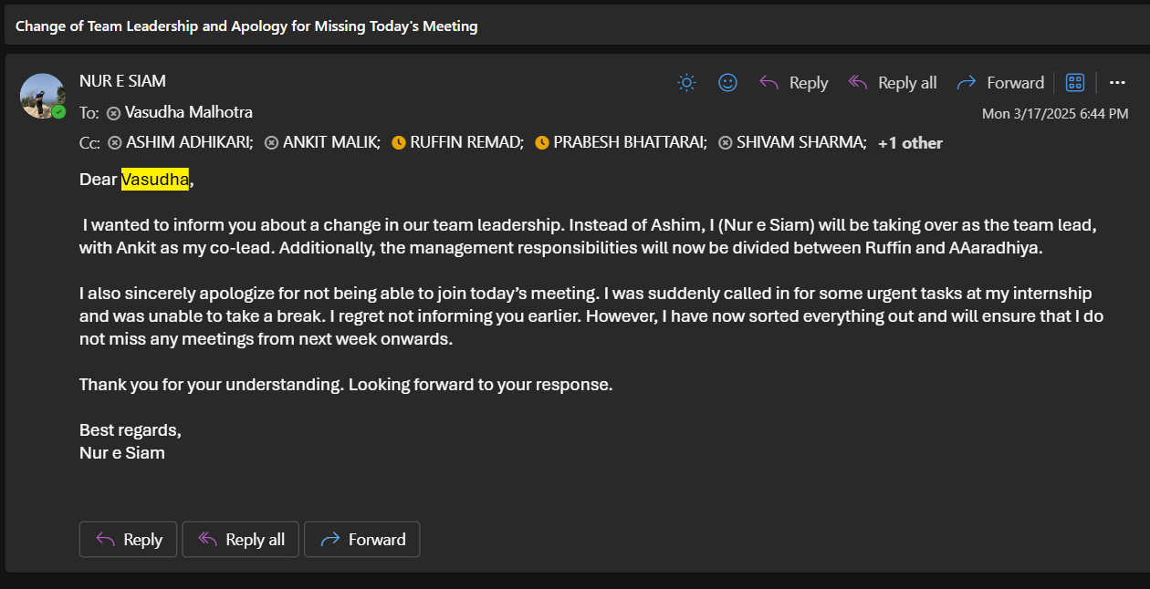
Figure 1. Change of team leadership

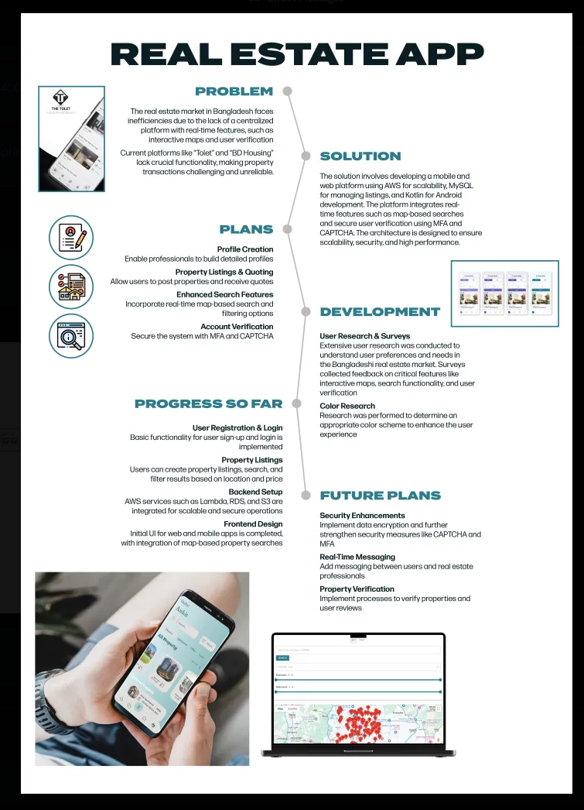
Figure 2. Capstone A final presentation poster

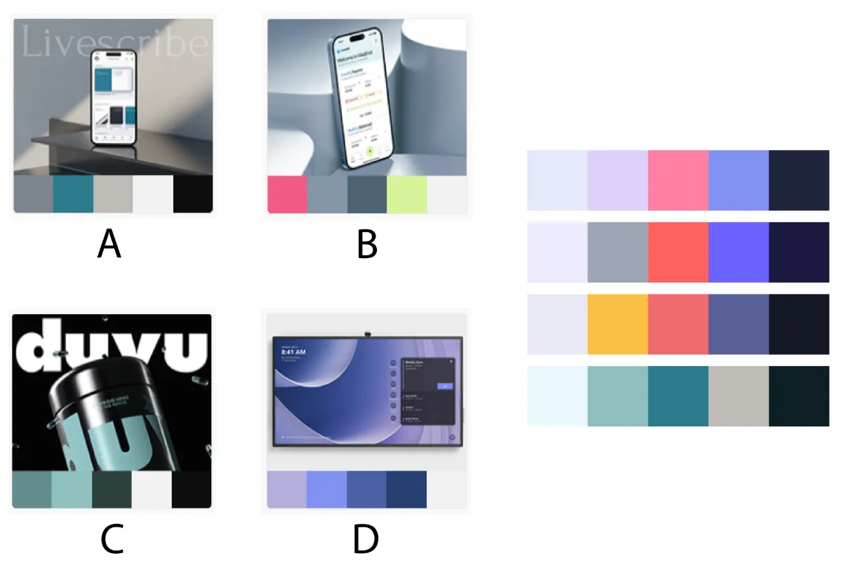
Figure 3. Testing of various colour schemes

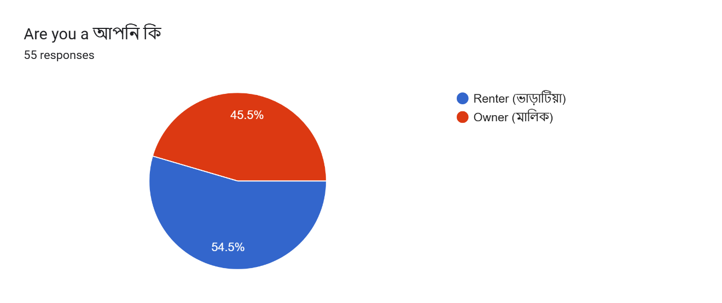
Figure 4. Survey question 1 responses

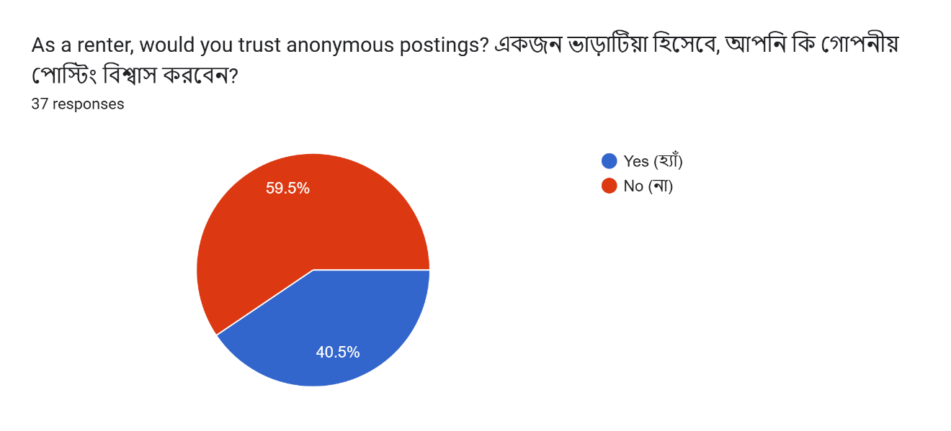
Figure 5. Survey question 2 responses

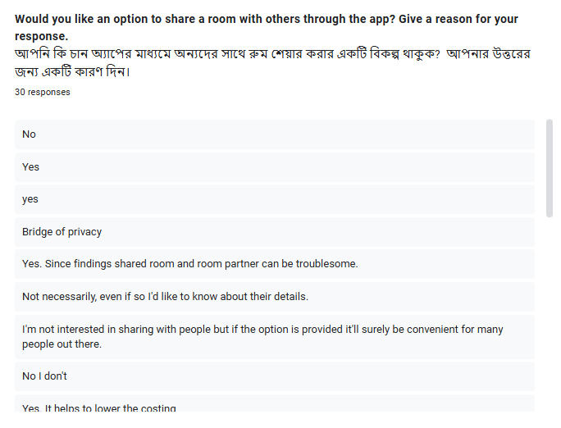
Figure 6. Survey question 3 responses (for renters only)

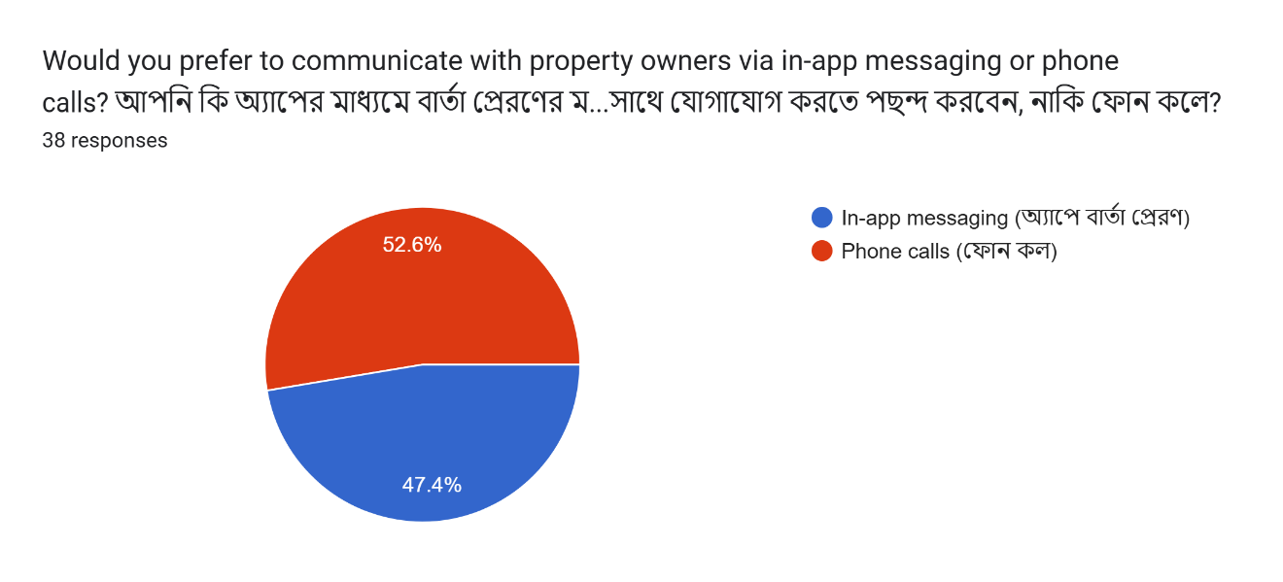
Figure 7. Survey question 4 responses (for renters only)

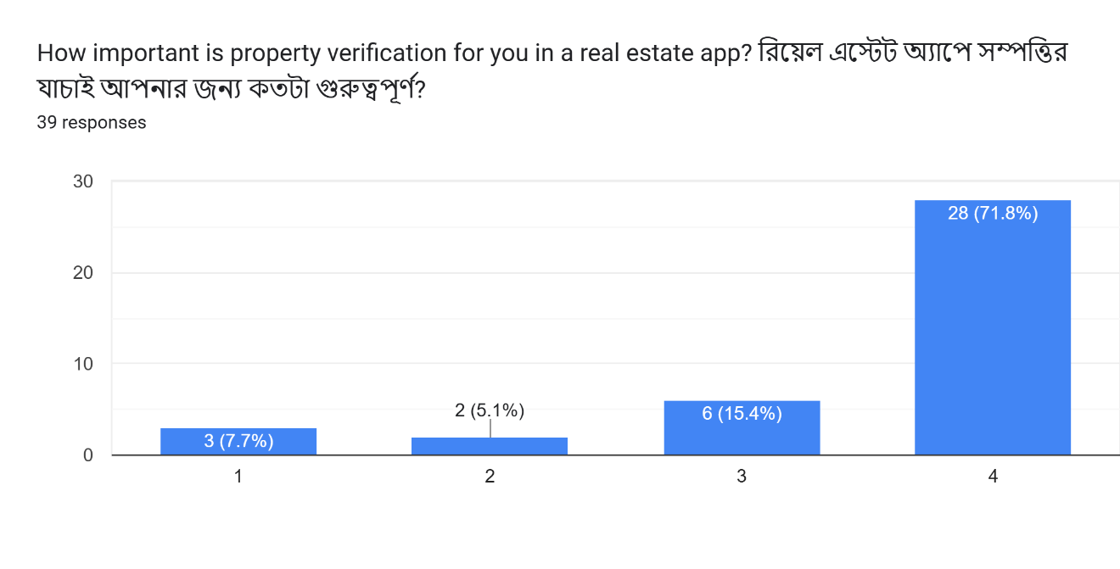
Figure 8. Survey question 5 responses (for renters only)

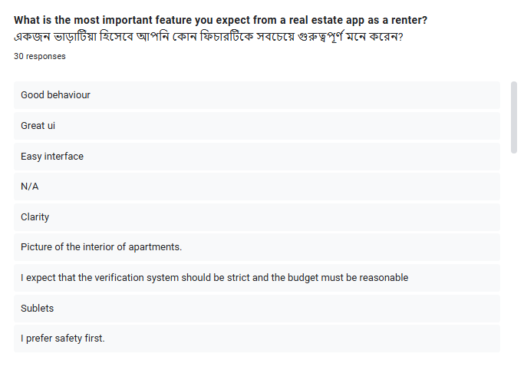
Figure 9. Survey question 6 responses (for renters only)

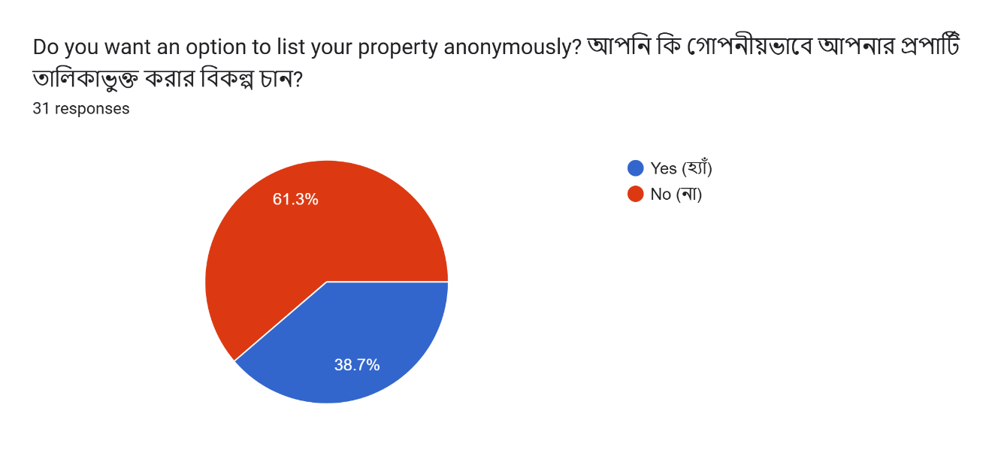
Figure 10. Survey question 7 response (for owners only)

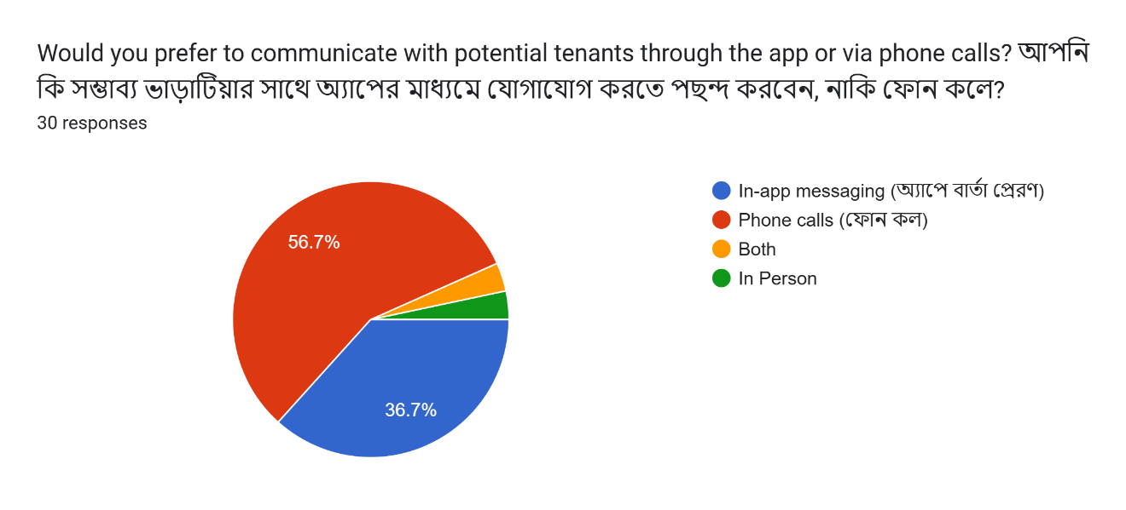
Figure 11. Survey question 8 response (for owners only)

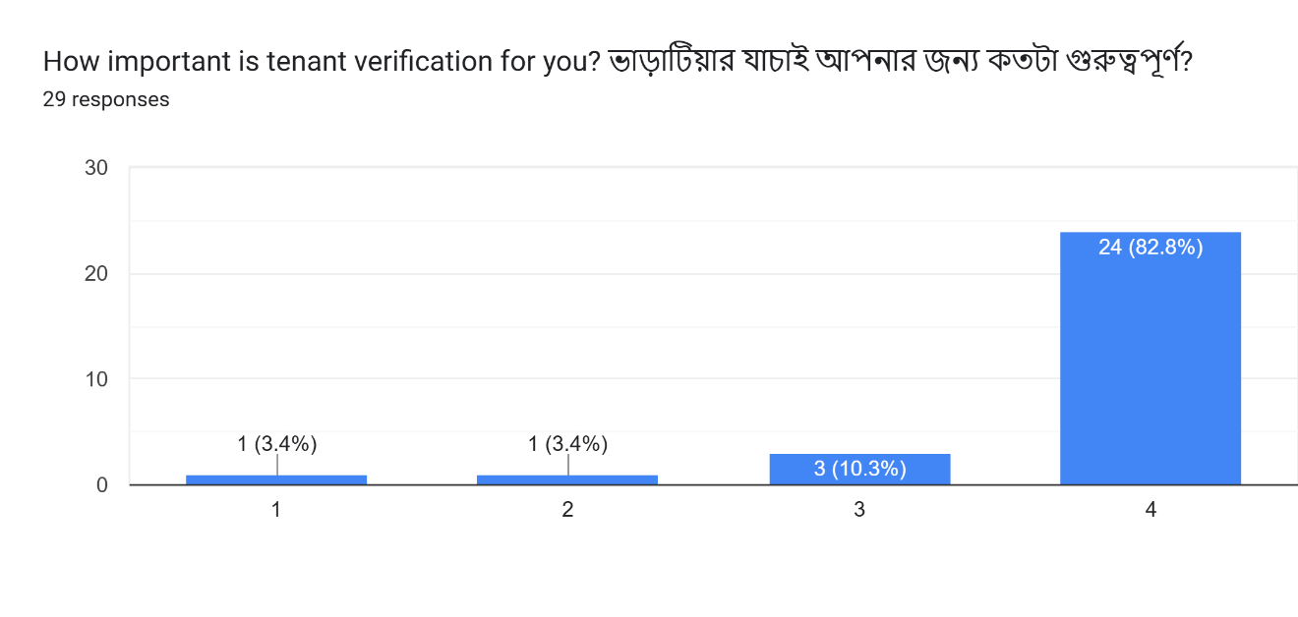
Figure 12. Survey question 9 response (for owners only)

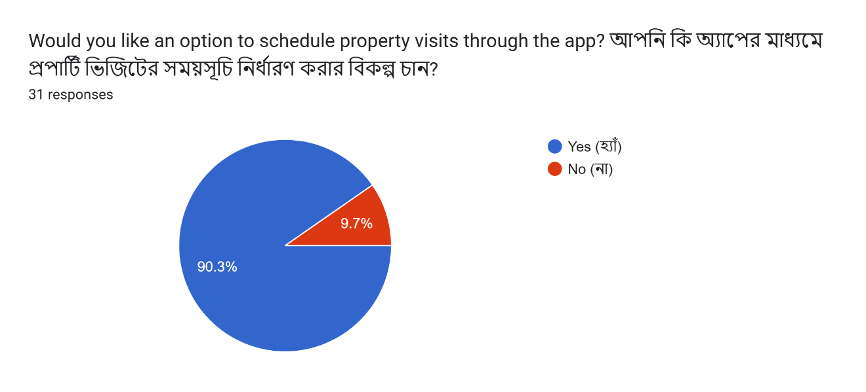
Figure 13. Survey question 10 response (for owners only)

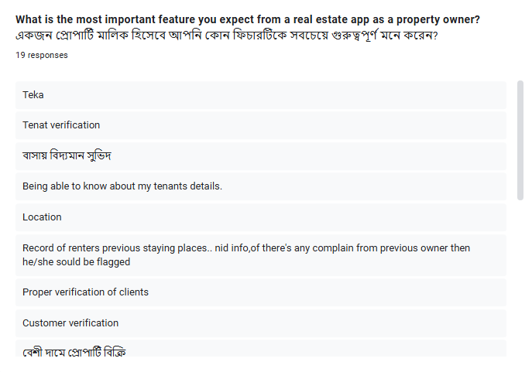
Figure 14. Survey question 11 response (for owners only)

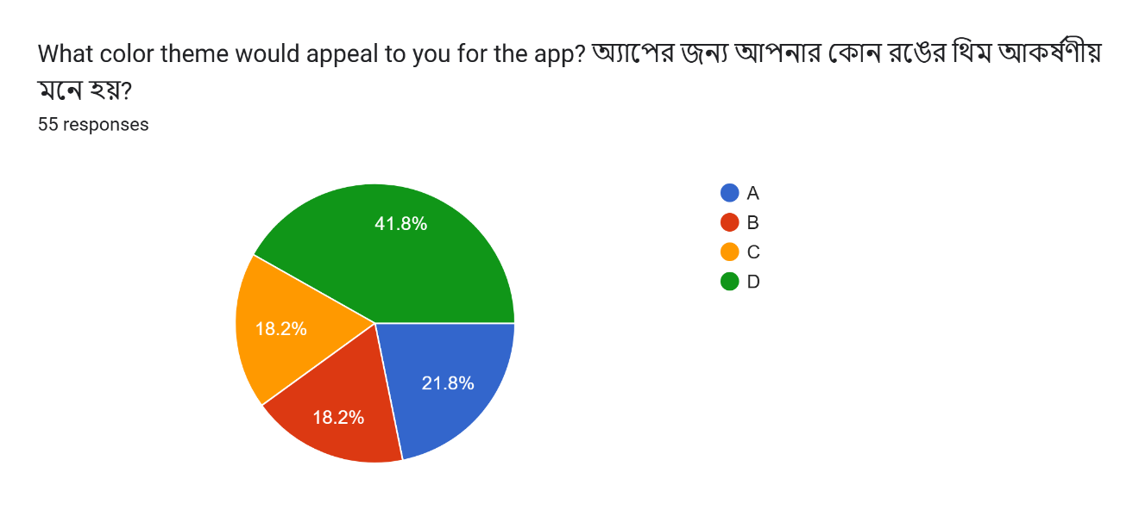
Figure 15. Survey question 12 responses (for renters and owners)

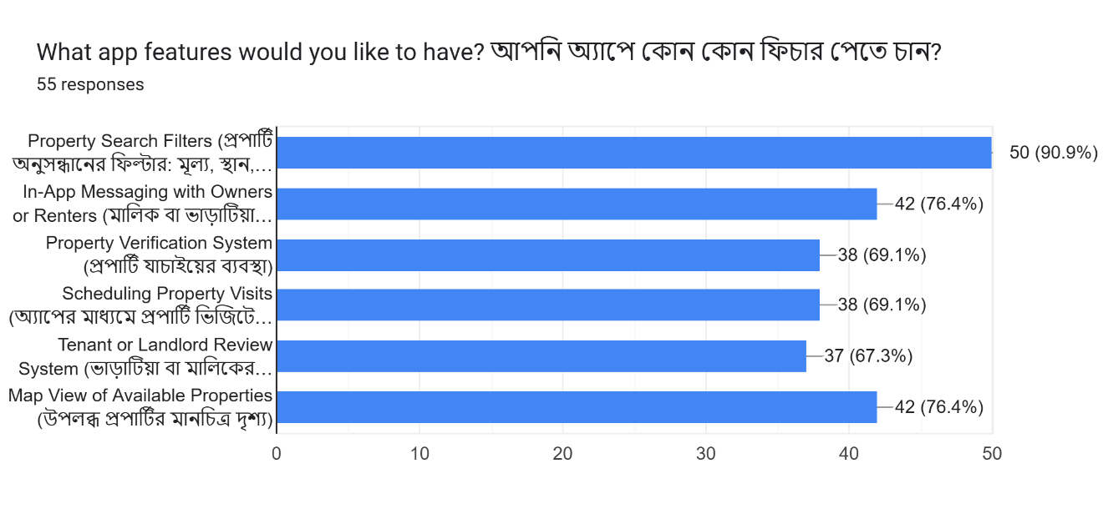
Figure 16. Survey question 13 responses (for renters and owners)

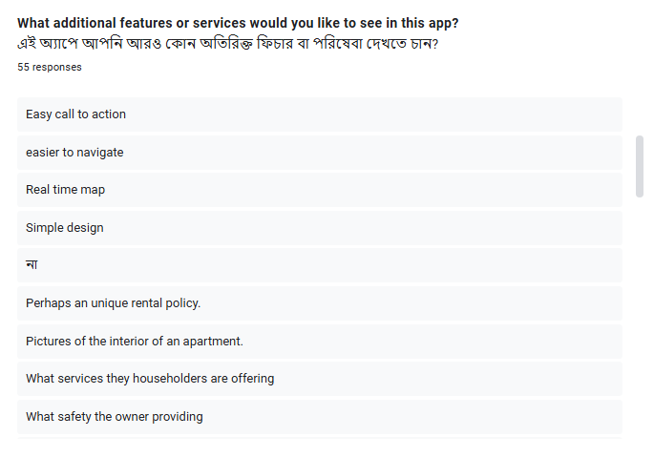
Figure 17. Survey question 14 responses (for renters and owners)

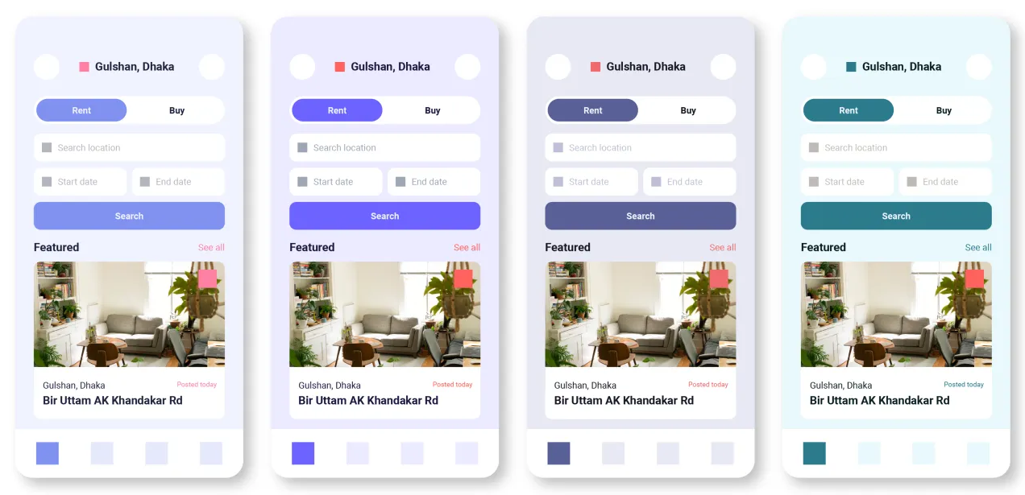
Figure 18. Final 4 colour schemes wireframes
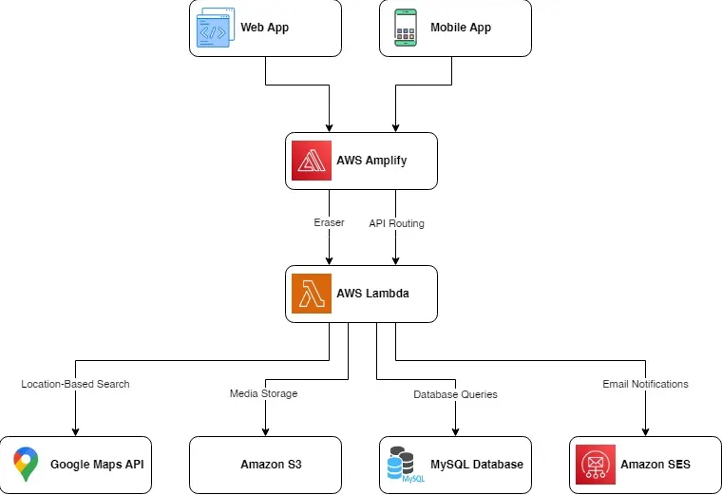
Figure 19. Architecture diagram

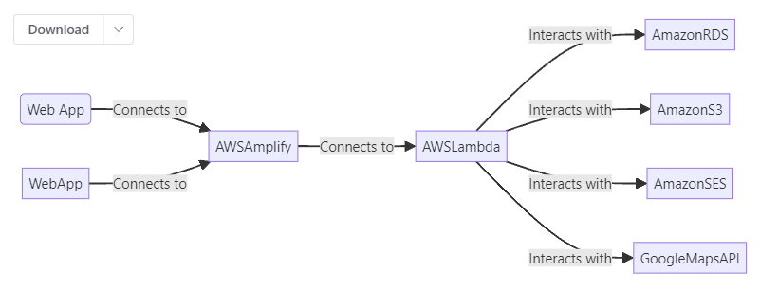
Figure 20. AWS diagram

